1. Format all cells -> Autofit column width
2. Set BIRTH_DATE and DEATH_DATE to date format
3. Data validation for PREFIX – Ms., Mrs. or Mr.
4. Data validation for MARITAL – M or S
5. Special Latin characters are not displayed properly

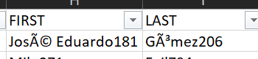

Import as File origin – Unicode (UTF-8)

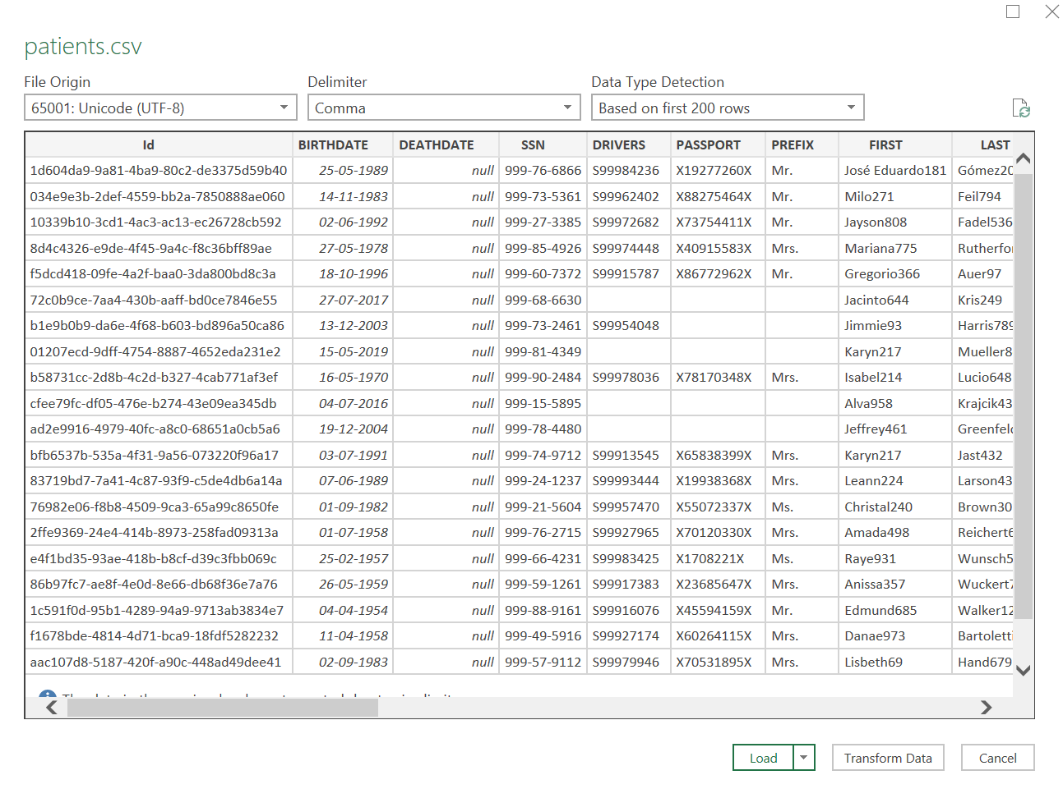

1. Remove unwanted numbers at the end of the names – FIRST, LAST & MAIDEN

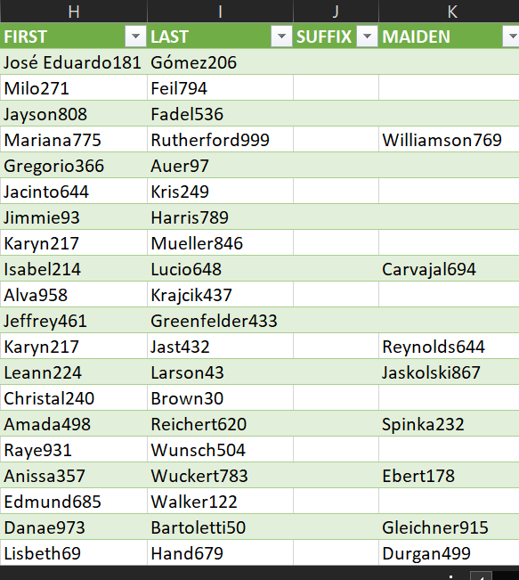

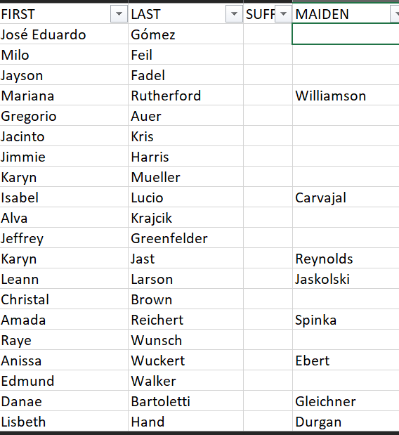

1. Set HEALTHCARE_EXPENSES and HEALTHCARE_COVERAGE to USD currency
2. Ensure LAT and LONG have consistent decimal places

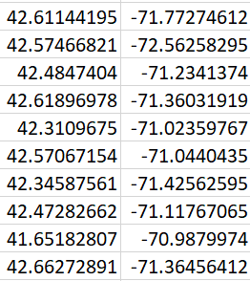 to 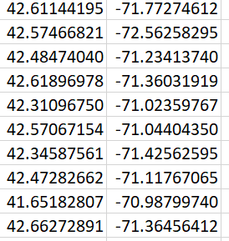

1. Fill missing values of DRIVERS, PASSPORT, MAIDEN and MARITAL with NA
2. Remove all the unnecessary spaces between words in BIRTHPLACE

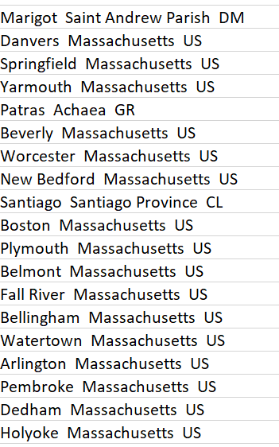 to 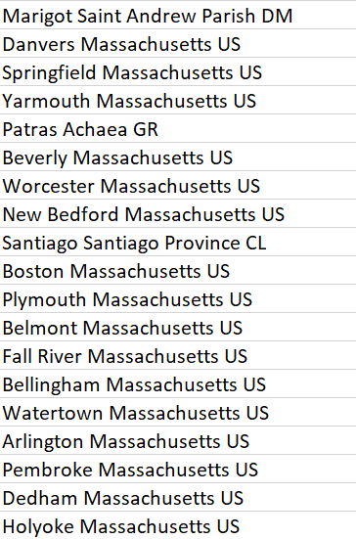

For further cleaning – one could fill missing ZIP code values using given LAT and LONG (eg using geocoding API)